AI/ML-Based Predictive Maintenance and Vehicle Health Monitoring System
Project Report — Module 3

1. Abstract
Modern vehicles contain multiple sensors that continuously monitor important operating parameters such as engine temperature, RPM, oil pressure, vibration, battery voltage, coolant temperature, fuel consumption and vehicle speed. Analysis of these parameters can help identify abnormal vehicle conditions before a major component failure occurs.
This project presents an AI/ML-Based Predictive Maintenance and Vehicle Health Monitoring System. The system collects vehicle operating data, preprocesses the sensor information and applies machine learning or deep learning models to estimate failure probability and vehicle health.
The proposed system produces a vehicle health score, failure probability and maintenance alert. Important contributing factors such as high vibration, rising temperature and abnormal oil pressure can also be identified. The system can therefore support predictive maintenance by providing an early indication of potential vehicle or component problems.

2. Introduction
Vehicle maintenance is an important part of automotive safety and reliability. Traditional maintenance approaches generally depend on fixed service intervals or inspection after a problem has already occurred.
Predictive maintenance uses vehicle operating data to identify abnormal conditions and estimate the possibility of future failures. Artificial Intelligence and Machine Learning can be used to analyze relationships between different vehicle parameters and vehicle health.
The proposed system uses information obtained from vehicle sensors and processes it through an AI/ML model. The resulting prediction is converted into a vehicle health score and failure probability, which can be used to generate maintenance alerts.

3. Problem Statement
Vehicle components can develop faults due to abnormal temperature, vibration, pressure and other operating conditions. If these conditions are not detected early, they can result in component damage, unexpected breakdowns and increased maintenance requirements.
The objective of this project is to develop a predictive maintenance and vehicle health monitoring system that analyzes vehicle sensor parameters and predicts the possibility of component failure before it occurs.

4. Objectives
- To monitor important vehicle operating parameters.
- To collect and preprocess automotive sensor data.
- To apply AI/ML techniques for vehicle health prediction.
- To estimate failure probability.
- To calculate a vehicle health score.
- To identify major factors contributing to abnormal vehicle conditions.
- To generate maintenance alerts when the predicted condition requires attention.
- To support predictive rather than purely reactive vehicle maintenance.

5. Input Parameters
The proposed system uses the following vehicle parameters:
Parameter | Description
Engine Temperature | Indicates the operating temperature of the engine
RPM | Represents engine rotational speed
Oil Pressure | Indicates the pressure of engine oil
Vibration | Represents mechanical vibration of vehicle components
Battery Voltage | Indicates electrical system/battery voltage
Coolant Temperature | Represents engine coolant temperature
Fuel Consumption | Indicates fuel usage
Vehicle Speed | Represents vehicle operating speed
Operating Hours | Represents the duration of vehicle operation

These parameters form the input to the data-processing and machine-learning pipeline.

6. AI/ML Technologies
The project can use different machine-learning and deep-learning models depending on the available dataset and prediction requirement. The specified AI/ML technologies include:
- Random Forest
- XGBoost
- LSTM
- Explainable AI (XAI)
Other models identified for the project include:
- Logistic Regression
- Decision Tree
- Random Forest
- XGBoost
- LSTM
- GRU
- Transformer

7. System Architecture
The proposed architecture represents the flow of information from vehicle sensors to the final maintenance decision, as shown below.
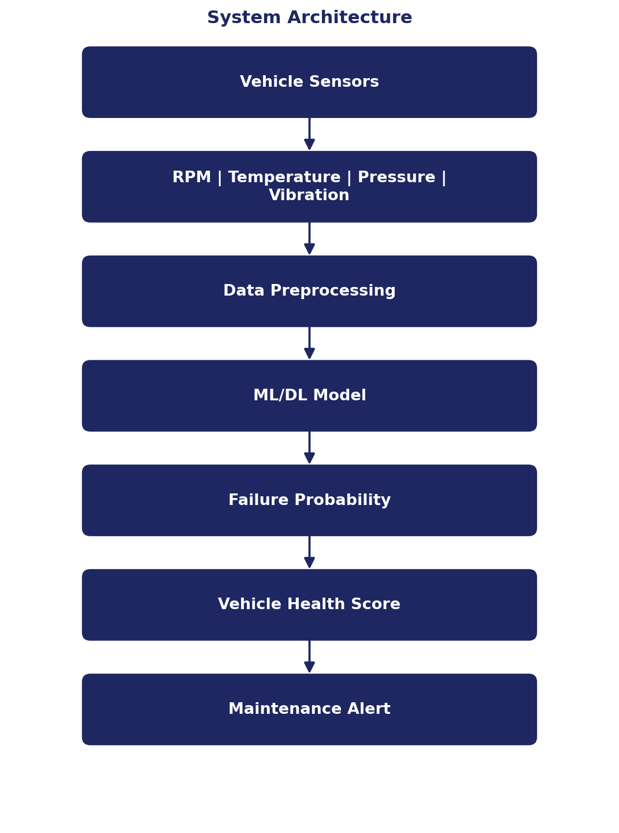
Figure 1. System architecture — from vehicle sensors to maintenance alert.

8. Architecture Description

8.1 Vehicle Sensors
Vehicle sensors provide real-time operating information. Parameters such as RPM, temperature, pressure and vibration are collected from the vehicle.

8.2 Data Preprocessing
The collected sensor data is processed before being supplied to the machine-learning model. Preprocessing may include:
- Removing invalid records
- Handling missing values
- Normalizing numerical parameters
- Preparing input features
- Organizing sensor observations into a suitable dataset

8.3 ML/DL Model
The processed sensor information is provided to an appropriate machine-learning or deep-learning model. Models such as Random Forest, XGBoost, LSTM and other listed models can be used depending on the structure of the data and prediction objective.

8.4 Failure Probability
The trained model produces a prediction related to the possibility of vehicle or component failure. The failure probability provides an indication of the risk associated with the current vehicle condition.

8.5 Vehicle Health Score
The predicted vehicle condition can be represented using a vehicle health score. A higher health score represents a healthier operating condition, while a lower score indicates that the vehicle may require attention.

8.6 Maintenance Alert
When abnormal conditions or high failure probability are identified, the system generates a maintenance alert.

9. Methodology

Step 1: Data Collection
Vehicle sensor data is collected using the specified input parameters.

Step 2: Data Preprocessing
The collected data is cleaned and prepared for machine-learning analysis.

Step 3: Feature Preparation
Important vehicle parameters are selected as input features for the prediction model.

Step 4: Model Training
A suitable machine-learning or deep-learning model is trained using historical vehicle operating data.

Step 5: Failure Prediction
The trained model analyzes new sensor observations and predicts the possibility of vehicle/component failure.

Step 6: Health Score Generation
The prediction is converted into a vehicle health indication.

Step 7: Alert Generation
If the vehicle condition indicates a warning state, a maintenance alert is generated.

10. Data Processing Pipeline
The complete processing pipeline can be represented as shown below.
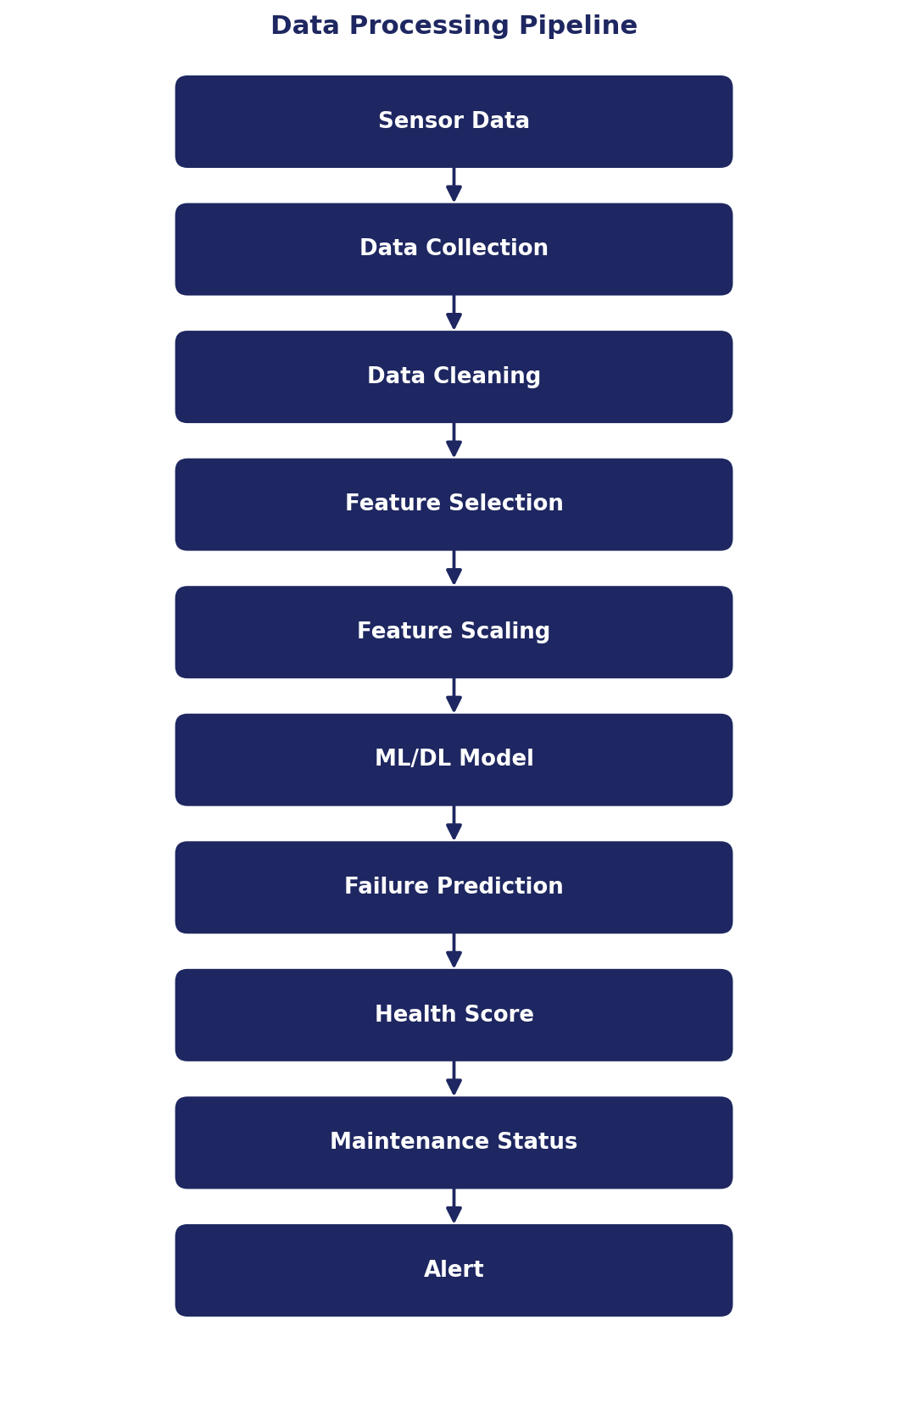
Figure 2. End-to-end data processing pipeline.

11. Machine Learning Model

Random Forest
Random Forest is an ensemble machine-learning approach that uses multiple decision trees to produce a prediction. It can be applied to vehicle sensor data containing multiple operating parameters.

XGBoost
XGBoost is a gradient-boosting-based machine-learning method that can be used for classification or prediction tasks. It can analyze relationships between different vehicle sensor parameters and failure conditions.

LSTM
Long Short-Term Memory networks are designed for sequential data. Since vehicle sensor readings can change continuously over time, LSTM can be considered for analyzing temporal patterns in vehicle operating data.

GRU
GRU is another recurrent neural-network architecture suitable for sequential data. It can be used when temporal relationships between vehicle sensor readings are important.

Transformer
Transformer-based architectures can also be considered for sequence-based vehicle data analysis where relationships between observations over time need to be modeled.

12. Explainable AI
Explainable AI can be used to understand which vehicle parameters contribute most significantly to a prediction. For example, the system may identify:
1. High vibration
2. Rising temperature
3. Abnormal oil pressure
as major contributing factors to a warning condition. This makes the prediction more understandable and can help maintenance personnel identify possible areas requiring inspection.

13. Vehicle Health Monitoring
The system generates a health status based on the analyzed vehicle parameters. A sample output specified in the project requirements is shown below.
Sample Vehicle Health Output
Vehicle Health: 72%
Failure Probability: 68%
Status: WARNING
Major Contributing Factors: High vibration, rising temperature, abnormal oil pressure

The values above represent the sample output specified for the project and should not be treated as experimentally measured results.

14. Sample System Output
Parameter | Sample Value
Vehicle Health | 72%
Failure Probability | 68%
Status | WARNING
Major Factor 1 | High vibration
Major Factor 2 | Rising temperature
Major Factor 3 | Abnormal oil pressure

15. Maintenance Alert Logic
A simplified conceptual alert system can be represented as shown below.
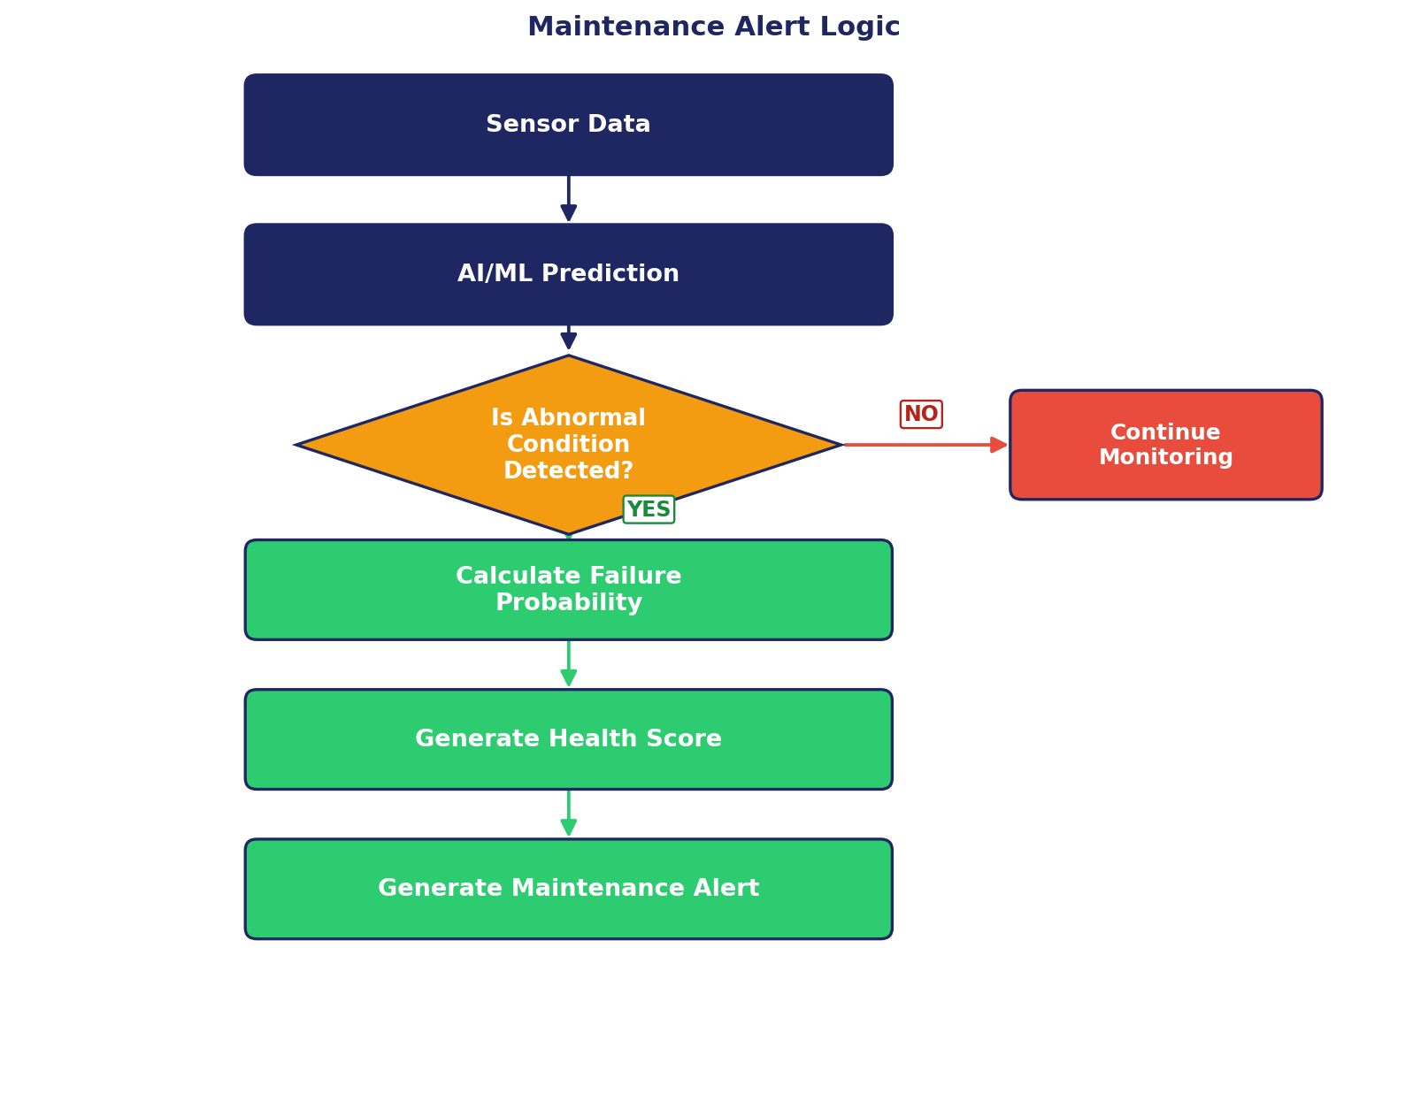
Figure 3. Maintenance alert decision logic.
If the analyzed parameters indicate a normal operating condition, the system can continue monitoring the vehicle. If abnormal patterns are detected, the system can generate a warning and identify the contributing parameters.

16. Applications
- Vehicle health monitoring
- Predictive maintenance
- Engine condition monitoring
- Component failure prediction
- Fleet monitoring
- Automotive service systems
- Early fault detection

17. Advantages
- Early identification of potential vehicle problems.
- Continuous monitoring of vehicle operating parameters.
- Reduction of dependence on fixed maintenance intervals.
- Ability to analyze multiple sensor parameters together.
- Failure probability estimation.
- Vehicle health scoring.
- Maintenance alert generation.
- Potential identification of major contributing factors using explainable AI.

18. Limitations
The effectiveness of the system depends on the quality and quantity of available vehicle sensor data. Other limitations include:
- Poor-quality sensor data can affect prediction quality.
- The machine-learning model requires suitable training data.
- Different vehicle models may have different operating characteristics.
- Sensor failures can affect the input data.
- Predictions should be validated before being used for critical maintenance decisions.
- A software prediction system does not replace physical inspection when required.

19. Future Scope
- Connecting directly to real vehicle sensors.
- Integrating an OBD-II interface.
- Developing a real-time vehicle health dashboard.
- Adding more vehicle components and failure types.
- Using larger automotive datasets.
- Comparing multiple ML/DL models.
- Implementing real-time alerts.
- Integrating cloud-based vehicle monitoring.
- Applying Explainable AI to improve prediction interpretability.
- Developing fleet-level predictive maintenance systems.

20. Expected Result
The proposed system analyzes vehicle operating parameters and uses AI/ML techniques to estimate vehicle health and failure probability. The expected output contains:
- Vehicle health score
- Failure probability
- Vehicle status
- Major contributing factors
- Maintenance alert
The system is intended to identify potential vehicle or component problems before failure occurs.

21. Conclusion
The AI/ML-Based Predictive Maintenance and Vehicle Health Monitoring System provides a framework for analyzing vehicle sensor data and predicting potential component failure.
The system combines vehicle sensor parameters, data preprocessing and machine-learning/deep-learning models to estimate failure probability and vehicle health. The resulting health status and maintenance alert can provide an early indication of abnormal vehicle conditions.
The proposed architecture demonstrates how artificial intelligence can be integrated with automotive connectivity and vehicle monitoring systems to support predictive maintenance and improve vehicle reliability.

22. References
1. Module 3 Connectivity Project Assignment.
2. Automotive sensor and vehicle health monitoring concepts.
3. Machine Learning and Deep Learning model concepts.
4. Random Forest and XGBoost model concepts.
5. LSTM, GRU and Transformer sequence-model concepts.

